- INTRODUCTION
The purpose of this document is to outline the deployment information related to the implementation of Robotics Process Automation (RPA) using UiPath for the process of Ookla RPA.
  - REFERENCES OF THE DOCUMENT
Sources:
https://www.uipath.com/blog/ultimate-rpa-glossary-of-terms
https://orchestrator.uipath.com/docs/robot-statuses
https://orchestrator.uipath.com/docs/about-assets

  - PROCESS DESCRIPTION
Ookla_RPA automates the extraction of latest file from the server then transferring it to another server. This process is a Back-Office Robot and does not need human intervention. It is scheduled to run every week on Friday at 8 AM.

  - SCOPE
The automated process covers all the activities for Ookla_RPA. This document covers the definition of terms used, requirements for running the script, workflows, and troubleshooting. This document also describes the process to be followed for assessing an incident and determining the level of priority based on definitions of impact and urgency.

- REQUIREMENTS
Ookla_RPA process requires the following applications:
- Chrome web browser
- UiPath web extension for chrome

  - TECHNICAL REQUIREMENTS AND ASSUMPTIONS / IT
Preconditions on Running the Robot
Before the bot can automatically run, we have to ensure the following:
- Package is uploaded in the orchestrator
- Robot is connected and available
- Schedule set in orchestrator is correct
- UiPath web extension is installed

  - REQUIREMENTS AND BUSINESS ASSUMPTIONS
N/A

- DIAGRAMS AND DESCRIPTION
  - PROCESS / BOT
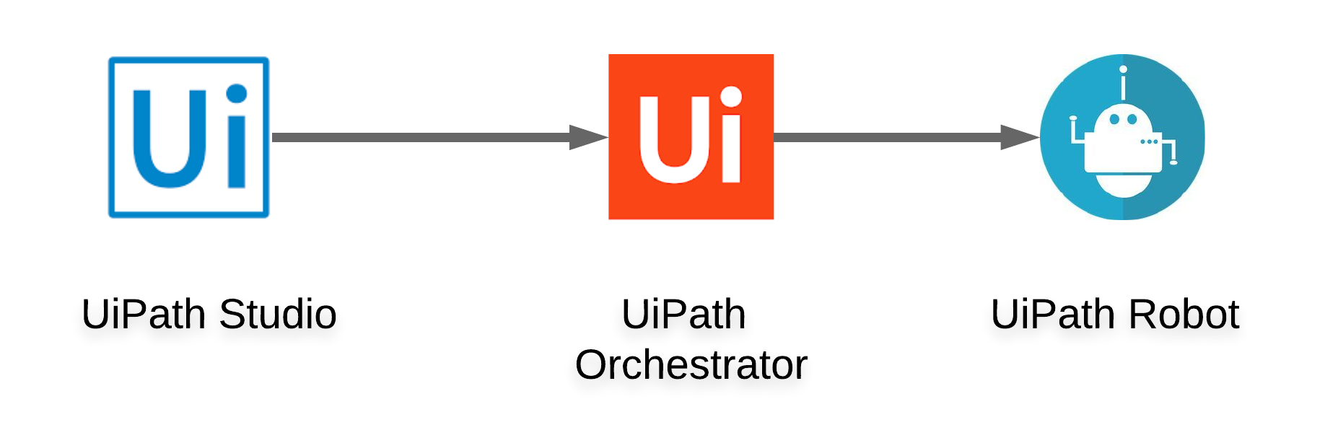
The package created from UiPath studio will be deployed to the UiPath Orchestrator. The Orchestrator will then pass the package to the robot. The robot is scheduled to run every week on Friday at 8 AM.

  - ACTIVITIES
- Ookla – Ooka_RPA automates the opening and signing in to the web site. https://extracts.ookla.com/files/v2
- FTP – Ookla_RPA used file transferring application to transfer files to another server

- GENERATION AND TREATMENT OF ALERTS AND EXCEPTIONS
Alerts will impact the process and business drivers. In this section if they number all the alerts and their method of communication. The definition of how to act in the face of all the alerts described should be in the ODH.
The process-lifting team must take the details and document the necessary procedures to react on those alerts in the PDD.
EVENT  (Alert or Exception) | SYSTEM OR BUSINESS | ROBOT ACTION AND DETAILS
Task Completed | System | Process is done

- DATA AND CREDENTIALS SECURITY
  - DATA STORAGE
This section is to detail all data storage locations (e.g. email, network folders, etc.) that touch the operation or belong to the operation.
The operation may be necessary to develop "managements" in these data storage locations according to the records management policies.

    - DATABASE
All transaction logs and jobs processed are all stored in the database where the UiPath Orchestrator is connected.

    - EMAIL
N/A

    - NETWORK UNITS / FOLDERS
FTP - 10.8.73.70@/apps/DASHBOARD/BROADBAND/done/RAW_DATA

    - OTHERS
N/A

  - DATA PRIVACY
All credentials that will be used in the process are stored in the UiPath Orchestra. All credentials stored here are encrypted with the AES 256 algorithm and can only be accessed by the one who manages it.

  - CREDENTIALS
Credentials are stored in the Orchestrator Community Edition and can be invoked by RPA developers when designing a process, but their values can be hidden from them. As stated in the Data Privacy, only the admin that manages it can change or remove the password.

- ASSISTED AUTOMATION PROTOCOL
METHOD | LOCATION | FORMAT | PROGRAMMING

- MANAGEMENT INFORMATION REPORTS (MI)
Communication Method
N/A

Format
N/A

Programming
UiPath uses Visual Basic programming language

- AUTOMATED MASTER PROJECT DETAILS
Details filled in by the developer reflect the actual information for the master project released for production.
 | PROJECT DETAILS | DESCRIPTION
1 | Master Project Name and Version | Ookla_RPA ver.1.1
2 | Robot Type (Specify if the process was automated for FOR or BOR or mix) | Ookla_RPA - BOR
3 | Is Orchestrator used? (Yes/No) | Yes
4 | Scalable? (Yes/No)(Can the process be run by multiple robots in parallel) | No

- PROJECT DETAILS
The robot will first open the browser then it will enter the credentials needed to access the webpage. The robot will extract the list of text from the webpage then it would be filtered to remove the unnecessary text and sorted in descending order. The robot will then download the file based on the sorted text and it will be transferred to 10.8.73.70 using FTP.
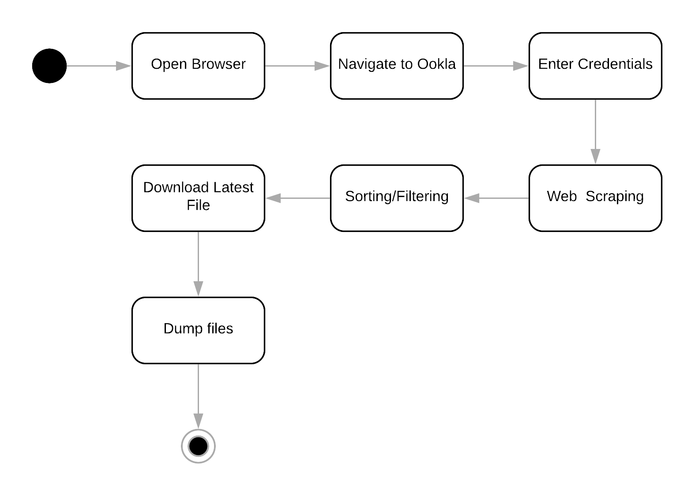
- OTHER DETAILS
  - FUTURE IMPROVEMENTS
Enhancement depends on the requirements.
  - DEBUGGING TIPS
If bot stop running, check the following:
- Robot/s stopped running the job; or
- Robot/s became Unresponsive or Disconnected
- Check logs in orchestrator
  - OTHER REMARKS
N/A
- POST UAT SPECIFICATIONS
Average duration per transaction: (varies depending on the Test environment)
Recommended number of robots for the specified volumes:
Specified schedule:

- DEFINITIONS
  - DEFINITION OF TERMS
TERMINOLOGY | DEFINITION
UiPath Studio | A software used for developing automation tool
UiPath Robot/Assistant | Executes the processes built in UiPath Studio
UiPath Orchestrator | A web application that orchestrate UiPath Robots in executing repetitive business processes
Asset | Represents shared variables or credentials that can be used in different automation projects.

  - ACRONYMS
ACRONYM | DEFINITION
RPA | Robotics Process Automation
VPN | Virtual Private Network
FTP | File Transfer Protocol

